(Approx. 662 words)

Setting WIN7 Default Applications
By Dick Maybach
June 2012 issue, BUG Bytes, Brookdale Computer Users’ Group, NJ
www.bcug.com
n2nd (at) charter.net

Windows 7 offers a convenience that previous versions had – when you double-click on a file icon in its file manager, an appropriate application program starts and opens the file. However, you may disagree with Windows about what is appropriate. Fortunately, it is easy to make a one-time over-ride of the default or permanently change it to what you prefer.

Windows uses the file's extension to identify the file type and to select the application to use for it. The extension is the text that follows the last period (.) in the filename. For example, .doc or .docx identifies an MS Word file, and its default application is usually MS Word. Windows 7 is often configured to hide file extensions, but you can change this by navigating to Control Panel ® Appearance and Personalization ® Folder Options, selecting the View tab, and removing the check from the item Hide extensions for know file types, as shown in the screen shot below.
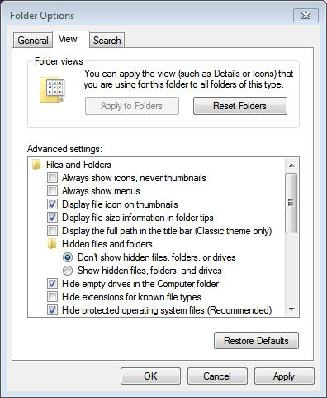

I prefer this because I can look at a list of files and immediately see which are, for example, text, music, or spreadsheets.

While using Windows Explorer, double-clicking on a filename will start an application and open the file with it. If you want to open it with a different application, right-click on the filename, then click on Open with. The screen-shot below shows the result, which is a list of the applications that can open the file (a JPEG image in this case). To change the application that starts when you double-click a file with this extension, click on Choose default program …, and select a new default for all files with the same extension (.jpg in this case).
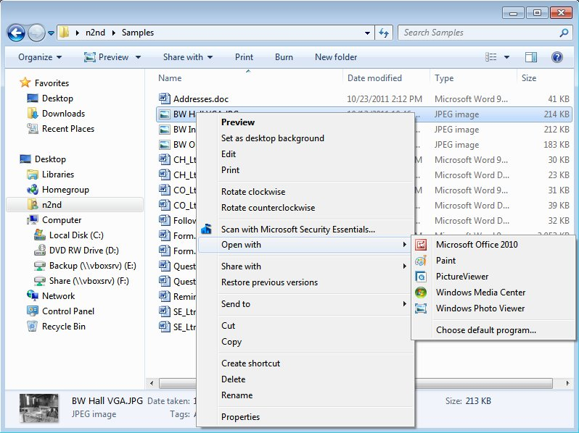

The above approach is tedious if you, for example, wanted to change the default application for all image files, not just JPEG ones. In this case, you would probably prefer the following. Use the sequence Start ® Control Panel ® Programs ® Set your default programs. You will see a list of all the programs that have been as defaults. Select one and click on Choose defaults for this program. The screen below shows the result for Windows Photo Viewer, which is a list of all the file types that this application can open. Note that the only image type is isn't currently assigned to is GIF image. You could change this by selecting GIF and clicking on the Save button.
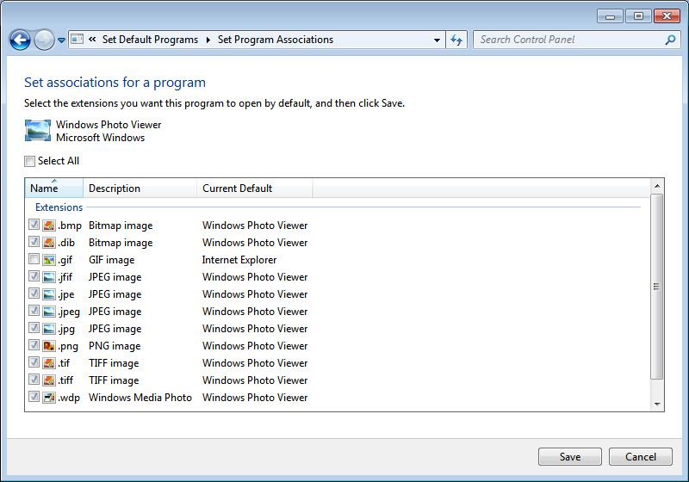
This approach doesn't always work – the list of default programs is incomplete, and applications that are not already defaults won't appear. A more robust, but more tedious, approach is to go back one window and select Associate a file type or protocol with a program instead of Set your default programs. (Before taking the screen-shot, I had clicked on the heading Current Default, which sorts the display by default application, Windows Photo Viewer in this case).
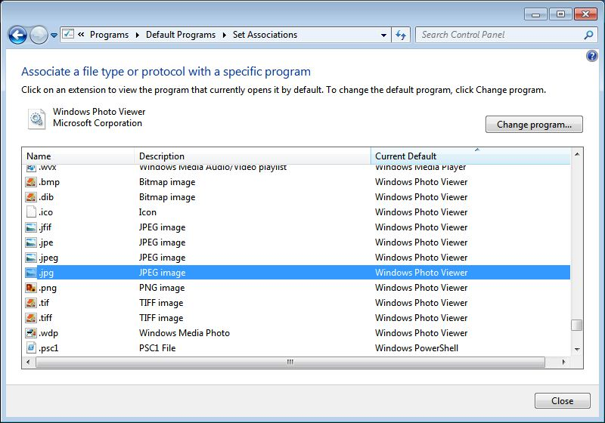

To change a default, just select the program type, click the Change program … button, and select the application. Since many different image file types appear together, it is must easier if you want to change them all. You would probably scan the entire list in case some image files were assigned a different default, and of course, you have no assurance that the application you select can actually open the file.

While we are discussing defaults, you can also select what happens when you insert a disc in your DVD drive. Use the sequence Start ® Control Panel ® Programs ® Change AutoPlay settings. The screen-shot below show the result of selecting the Choose a default button in the Audio CD line.
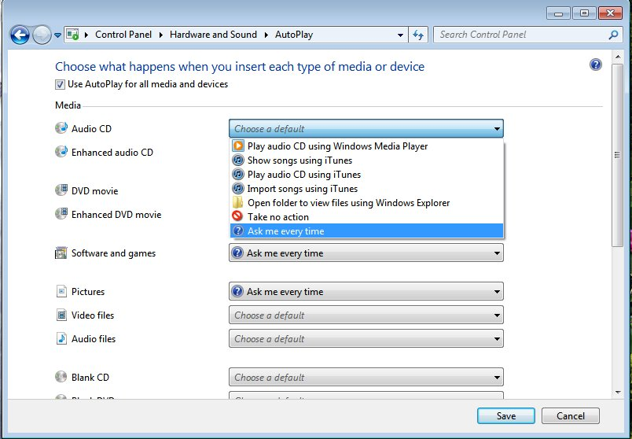

My PC is set up to take no action, but I could pick any action on the list.

By setting the defaults you can adapt your Windows 7 computer to your own preferences and make it easier and faster to use.

